Lab 15 Backing Up and Restoring Systems and Data
This lab contains the following exercises and activities:
- Exercise 15-1: Using the Backup Utility
- Exercise 15-2: Starting the Recovery Console
- Exercise 15-3: Creating an ASR Recovery Set
- Exercise 15-4: Using System Restore Points
- Lab Review Questions

Scenario
Contoso, Ltd., requires that all its file servers maintain recent backups so that if a disaster ever strikes, technicians can quickly restore data to the old servers or to new servers.
To accomplish this, technicians must be familiar with the Backup utility and normal and differential backups. Contoso uses both these backup types in its backup scheme.
Also, Contoso wants all its technicians to be familiar with the Recovery Console and Automated System Recovery (ASR). This is so that in a disaster where even safe mode is unavailable, repairs can still be made through the Recovery Console, and if that fails, the ASR recovery set can be used.
Finally, many system configuration problems, especially those created by overzealous users, can be fixed using system restore points.
After completing this lab, you will be able to:
- Backup and restore files using the Backup utility.
- Start a recovery using the Recovery Console.
- Create an ASR recovery set for automated recovery.
- Create and use system restore point to restore past system configurations.

Before You Begin
There are no prerequisites for this lab.
Exercise 15-1: Using the Backup Utility
Contoso uses the following backup scheme. A normal backup is made of critical data once a week, late at night on Sundays. Each day, a differential backup
is created as a file. The file is then copied by an employee off of the computer on which it was created onto a removable medium.
By splitting the backup duty out from the removable media copy duty, security is increased, because the person responsible for making the copy to the removable media of the differential backup file has no control over what is contained in the other backup file.
Backing Up Data and the System State
You must create a routine, differential backup of the System State data along with some critical data.
- Log on with your local Administrator account (the password is P@sswOrd).
- From the Start menu, select My Documents.
- In My Documents, create a new folder and name it Cache.
- From the Start menu, point to All Programs, Accessories, System Tools, and then select Backup.
- In the Backup Or Restore Wizard, on the Welcome To the Backup Or Restore Wizard page, clear the Always Start In Wizard Mode check box.
- Close and restart the Backup Utility program.
- Click Advanced Mode.
- In the Backup utility, on the Backup tab, in the directory tree, select the My Documents check box and the System State check box, as shown in the following figure.
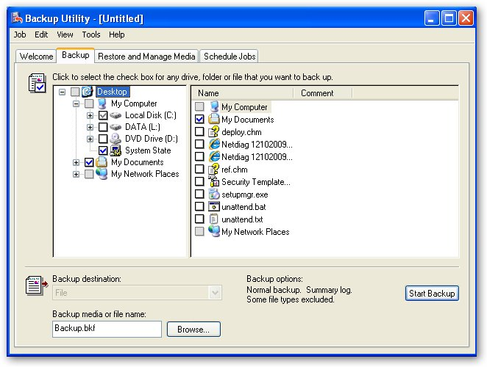
Question 1: When System State is selected (the name and the check box) in the directory tree, why are the check boxes in the detail pane unavailable (grayed out)?
- From the Tools menu, select Options.
- In the Options dialog box, in the Default Backup Type drop-down list, select Differential.
Question 2: Fill in the following table with the description for each backup type in the dropdown list.
Backup type | Description
Normal
Copy
Differential
Incremental
Daily

Question 3: Assume this is the third differential backup of these selections that you have made since the last normal backup. To restore this information to the state of this backup, how many of the four backups (the normal and the three differential) will you have to restore?
Question 4 Given that you have selected Differential backup, what type of backup method will be applied to the System State information?
- On the Exclude Files tab, under Files Excluded For All Users, click Add New.
- In the Add Excluded Files dialog box, click Browse.
- In the Exclude Path dialog box, expand My Documents and then select the Cache folder. Click OK.

Note:*.dat for the purposes of this lab, pretend that your My Documents folder contains databases used by an application used in the call centers named Proseware and that the Cache folder contains cached information that does not need to be backed up.
- In the Add Exclude box, in the Custom File Mask text box, type *.dat and ensure that the Applies To All Subfolders is check, Click OK.
- On the General tab, ensure that the following check boxes are cleared
- Show alert message when I start the Backup Utility and Removable Storage Is not running
- Show alert message when I start the Backup Utility and there is recognizable media available
- Show alert message when new media is inserted
- Always allow use of recognizable media without prompting
TIP Clear these check boxes when you are backing up to a file and then copying to another media. Select them when you are backing up directly to another media.
- The General tab should look like the following figure.
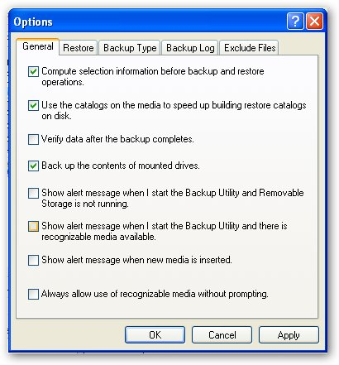
- Click OK
- Click Browse next to the Change The Backup Or Media File Name text box.
- Click Save to save Backup.bkf (the default name)
- In the Backup utility, on the Backup tab, click Start Backup.
- In the Backup Job Information dialog box, select Replace The Data On The Media With This Backup option.
Question 5: What options becomes available when you select Replace The Data On The Media With This Backup?
- Click Start Backup.
- The Backup Progress dialog box will appear and indicate progress. This task can take anywhere from 5 minutes to 15 minutes or more.
Question 6: When the backup is under way, you might notice in the Status text box that the message "Preparing to backup using shadow copy" appears. What is shadow copy, and why is it being used?
Question 7: When the backup is completed fill in the following table
Drive
Label
Status
Elapsed time
Files (Processed)
Bytes (Processed)

- When the backup is complete, click Close.

Restoring Data
- In the Backup utility, click the Restore And Manage Media tab.
- In the directory tree, expand File, Backup.bkf Created Date and Time, C:, Documents And Settings, Administrator, and My Documents, and then select the My Pictures check box.
Question 8: Why do the other folders also have a check in the box?
Note: A file server would not contain shared files in this location; it is used here only as an example for restoration.
- Click Start Restore.
- In the Confirm Restore message box, click OK to begin the restore.
- The Restore Progress dialog box will appear and indicate progress. Click Close when the restore is completed.
- Close the Backup utility.
Exercise 15-2: Starting the Recovery Console
A system is freezing on startup, and Safe Mode will not boot either. You have decided to first start the Recovery Console and complete a check on drive C.
- Ensure that your Windows XP Professional installation CD is in your CD-ROM drive, and that the BIOS is set to boot from the CD-ROM drive before the hard drive, and then restart your computer. If prompted to press any key to boot from the CD-ROM drive, do so.
- Windows XP Professional Setup will start and load a curtailed version of the Windows XP operating system.
- On the Welcome To Setup page, press R to start the Recovery Console.
- Select your operating system by pressing 1 (it should be the only one), and then press ENTER.
- Type your local Administrator password when queried.
- At the command prompt, type help, and press ENTER.
Question 9: What does the statement at the top say?
- Press Esc.
- At the command prompt, type chkdsk▲/? and then press ENTER.
Question 10: Fill in the following table with the explanation for each part of the chkdsk command.
[drive:]
/P
/R

Question 11: Can chkdsk be run without parameters?
Question 12: where is the Autochk.exe file located?
- At the command prompt, type chkdsk▲c:▲ /p and then press ENTER.
- Chkdsk will perform a check on drive C. When the check is done (which could take 5 minutes or more),
Question 13: Fill in the following table;
How many total kilobytes of disk space?
How many kilobytes available
How many bytes in each allocation Unit?
How many total allocated units on the disk?
How may allocated units are available on the disk?

- type exit to restart your computer.
- Remove the installation CD from the drive.
- Start Windows XP normally.
Exercise 15-3: Creating an ASR Recovery Set
System recovery can be greatly simplified if you create an Automated System Recovery (ASR) set. This includes a set of backup files and a floppy disk that con¬tains a list of the system files that are installed on the computer. Using these two items, you can easily rebuild a downed server. Although the backup set required is too large to create in a lab environment, you can create and find the files that are copied to the ASR floppy disk.
- Log on locally with your Administrator account.
- Open the Backup utility.
- In the Backup utility, on the Welcome tab, click Automated System Recovery Wizard.
- In the Automated System Recovery Preparation Wizard, on the Welcome page, click Next.
- The Backup Destination page will appear.
Question 14: What is the path to the Backup media or file name?
- click Next.
- On the Completing The Automated System Recovery Preparation Wizard page, click Finish.
- In the Replace Data message box, click Yes to replace the existing backup file.
- The backup process will begin.
- Quickly In the Backup Progress dialog box, click Cancel.
- In the Backup Utility message box, click Yes to confirm the cancellation.
- In the Backup Progress dialog box, click Close.
Note Ordinarily, you would allow the backup set to complete (but it takes too long to do it now), at which time you would be asked for a floppy disk. The wizard would then copy the appropriate files to the ASR floppy disk.
- Close the Backup utility window.
- From the Start menu, select My Computer.
- Browse to the location C:\Windows\Repair.
- Right-click on the Asr.sif file and select open.
- Open the Asr.sif in notepad.
Note Asr.sif and Asrpnp.sif are the files that are required to be on the ASR recovery disk. You can view these files in Notepad to examine their contents.
Question 15: In the open the Asr.sif file and write what the first line says.
- Close notepad and open the Asrpnp.sif file in notepad.
Question 16: What does this file show and what does pnp stand for?
- Close the Repair window.
Exercise 15-4: Using System Restore Points
A user said that her DVD/CD ROM drive was unable to read a particular DVD disk, so she "changed some settings" and now her DVD/CD ROM drive won't work at all.
The user has contacted you over the phone, and you have decided to walk her through using the System Restore Wizard.
Creating a Restore Point
Presumably, you would instruct the user to use the last restore point automatically created. But for the purposes of this lab, you will create your own restore point.
- From the Start menu, point to All Programs, Accessories, System Tools, and then select System Restore.
- In the System Restore wizard, on the Welcome page, select Create A Restore point.
- Click Next.
- On the Create A Restore Point page, in the Restore Point Description text box, type Before DVD/CD-ROM Was Broken and then click Create.
- On the Restore Point Created page, click Close.
Creating the Problem
The following steps will disable the DVD/CD ROM drive as a simulation of the problem.
- From the Start menu, right-click My Computer and then select Manage.
- In the Computer Management console, under System Tools, select Device Manager.
- In the details pane, expand DVD/CD ROM drives, right-click Sony DVD-ROM DOU1612, or a similar entry and select Properties.
- In the pull-down for Device usage select Do not use this device (disable).
- Click on OK
Question 17: What symbol appears in front of the Sony DVD-ROM DOU1612 listing?
- Close the Computer Management console.

Using System Restore
The following steps will restore to the point that you created earlier in this exercise.
- Open the System Restore wizard.
- In the System Restore wizard, on the Welcome page, ensure that Restore My Computer To An Earlier Time is selected, and then click Next.
- On the Select A Restore Point page, in the list box, select Before DVD/CD-ROM Was Broken.
Question 18: Summarize what the warning dialog box says. .
- Click next
- On the Confirm Restore Point Selection page, click Next.
- A System Restore message box will appear and indicate progress, after which your computer will restart.
- Log on locally with your Local Administrator account.
Question 19: Summarize the red areas in the window that appears.
- On the Restoration Complete page, click OK.
- From the Start menu, right-click My Computer and then select Manage.
- In the Computer Management console, under System Tools, select Device Manager.
- In the details pane, expand DVD/CD ROM drives
Question 20: What has changed?
- Close the Computer Management console.
- Open System Resotre.
Question 21: What new option appears on the Welcome to System Restore page?
- Close all windows
- Shutdown the computer.

Lab Review Questions
1. What is backed up when you select the System State for backup?
2. What are the five backup types, and how does each relate to the archive attribute? (Hint: The archive attribute is set to denote a file for backup and can be cleared to mark the file as backed up. Given this information, you can deduce the treatment of the archive attribute for each backup type by reading its description in the Options dialog box in the Backup utility.)
3. There are three options when restoring a backup set as to where the files are to be restored. What are the options, and what do they do?
4. You are about to install third-party drivers for a legacy device that does not have signed drivers. You are suspicious of the drivers. What feature can you use so that you can easily undo the configuration if it fails?

